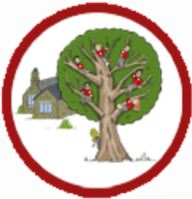
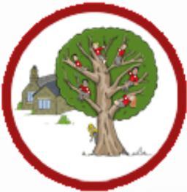
Launton Church of England Primary School

Music EYFS

 | Listening and Responding to Music | Explore and Create | Singing | Share and Perform
Year group N | Children sing songs daily and learn some Nursery Rhymes.  Children exploring different instruments and make different sounds within Continuous Provision.  Adults play music for children to move and dance to, using songs with actions.  Children learn the names of instruments –drum, tambourine, bells.  Children listen with increased attention to sounds. They respond to what they have heard, expressing their thoughts and feelings.  Children respond to different genres of music and talk about how it makes them feel. | Children find the pulse by copying a character in a nursery rhyme, imagining a similar character or object and finding different ways to keep the pulse.  Children copy basic rhythm patterns of single words, building to short phrases from the song/s.  Children explore high and low using voices and sounds of characters in the songs.  Children listen to high-pitched and low-pitched sounds on a glockenspiel.  Children invent a pattern using one pitched note, keep the pulse throughout with a single note and begin to create simple 2-note patterns to accompany a song or nursery rhyme. | Children learn to sing new songs.  They respond to different genres of music and talk about how it makes them feel.  Children sing songs that have a different pitch - go higher then lower.  Children begin remember and sing entire songs.  Children sing the pitch of a tone sung by another person (‘pitch match’).  Children sing the melodic shape (moving melody, such as up and down, down and up) of familiar songs.  Children create their own songs, or improvise a song around one they know. | Children play instruments with increasing control to express their feelings and ideas.  Children perform nursery rhymes they have learnt to visiting adults.  Children are encouraged to share their performances with parents at home and via Tapestry.
Vocabulary | Pulse, rhythm, pitch, rap, improvise, compose, melody, bass guitar, drums, decks, perform, singers, keyboard, percussion, trumpets, saxophones, Blues, Baroque, Latin, Irish Folk, Funk, pulse, rhythm, pitch, groove, audience, imagination.
Evolving Musical Repertoire | Pitch high and low  Songs Wide range of familiar songs i.e. nursery rhymes  Styles Wide variety of musical styles as an introduction
Vocabulary | Song words, clap, stamp, move, dance, instrument, drum, tambourine, bells, loud, quiet, shake, tap, bang
Continuous provision | Listen to Music at transition times.  Instruments available in continuous prevision for children to explore and use creatively.
Year group R | Children know twenty nursery rhymes off by heart.  Children know the stories of some of the nursery rhymes.  Children sing songs daily.  Children explore different instruments and make different sounds within Continuous Provision.  Children learn to sing new songs for example for the Nativity performance.  Children respond with movement to different genres of music and talk about how it makes them feel.  Children learn names of instruments –drum, tambourine, bells, maracas, claves, glockenspiel and xylophone.  Children learn about the pulse in music and learn how to imitate this with their bodies.  Children keep a simple pulse with musical instruments. | Children can identify different instruments in the orchestra.  Children have opportunities to listen to musicians play their instruments live.  Children know that we can move with the pulse of the music.  Children know that the words of songs can tell stories and paint pictures. | Children learn to sing new songs.  They respond to different genres of music and talk about how it makes them feel.  Children sing songs that have a different pitch - go higher then lower.  Children remember and sing entire songs.  Children sing the pitch of a tone sung by another person (‘pitch match’).  Children sing the melodic shape (moving melody, such as up and down, down and up) of familiar songs.  Children create their own songs or improvise a song around one they know.  Children sing or rap nursery rhymes and simple songs from memory.  Children understand that songs have sections. | Children share and perform a Nativity.  Children understand a performance is sharing music.  Children play instruments with control to express their feelings and ideas.  Children perform nursery rhymes they have learnt to visiting adults.  Children are encouraged to share their performances with parents at home and via Tapestry.
Vocabulary | Keyboard, drums, bass, electric guitar, saxophone, trumpet, pulse, rhythm, pitch, improvise, compose, audience, question and answer, melody, dynamics, tempo, perform/performance, audience, rap, reggae, glockenspiel.
Evolving Musical Repertoire | Pitch I’m A Little Teapot C, C + D The Grand Old Duke Of York C, C + D Ring O’ Roses C, C + D Hickory Dickory Dock C, C + D The ABC Song D, D + E Wind The Bobbin Up D, D + E Rock-a-bye Baby D, D + E If You're Happy And You Know It G, G + A Old Macdonald Incy Wincy Spider G, G + A Baa Baa Black Sheep D, D + E Row, Row, Row Your Boat C, C + D Wheels On The Bus C, C + D The Hokey Cokey F, F + G Big Bear Funk D, D + E, D + C  Songs Pat-a-cake 1, 2, 3, 4, 5, Once I Caught a Fish Alive This Old Man Five Little Ducks Name Song Things For Fingers, I’m A Little Teapot The Grand Old Duke Of York Ring O’ Roses Hickory Dickory Dock Not Too Difficult The ABC Song Wind The Bobbin Up Rock-a-bye Baby Five Little Monkeys Jumping On The Bed Twinkle Twinkle If You're Happy And You Know It Head, Shoulders, Knees And Toes Old Macdonald Incy Wincy Spider Baa Baa Black Sheep Row, Row, Row Your Boat The Wheels On The Bus The Hokey Cokey Big Bear Funk  Styles Wide variety of musical styles as an introduction, Funk and Classical
Supporting Songs and Styles | 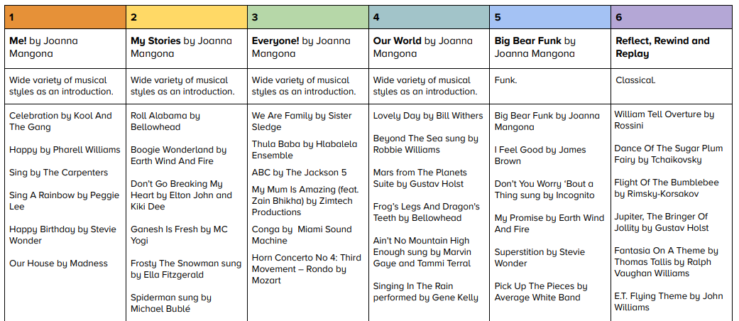
Continuous provision | Artist of the week and/or composer of the week during whole school assembly.  Lower School Singing Assembly Tuesday.  Listen to Music at transition times.  Instruments available in continuous prevision for children to explore and use creatively.
Retrieval practice | Display of musical instruments.  Re-listen to Artist of the week from assembly in class.

Launton Church of England Primary School

Music KS1

 | Pulse/Beat/Metre | Rhythm | Pitch (melody) | Tempo | Dynamics | Timbre | Texture | Structure (form)
Year group 1 | Watch, follow, feel and move to a steady beat with others. Find and enjoy moving to music in different ways. Respond to the pulse in recorded/live music through movement and dance. | Recognise and clap long sounds, short sounds and simple combinations. Perform short, copycat rhythm patterns accurately, led by the teacher. Perform short, repeating rhythm patterns (ostinati and riffs) while keeping in time with a steady beat. Perform word-pattern chants; create, retain and perform your own rhythm patterns. | Recognise, sing and play high and low-pitched notes. Explore singing and playing C, D, and E from the C major scale. Explore singing and playing F, G, and A from the F major scale. | Recognise the difference between the speed of a steady beat, a fast beat and a slow beat. | Talk about loud sounds and quiet sounds and give some examples. | Identify different sounds in the environment, indoors and outside. Identify the sounds of the instruments played in school. Identify some of the sounds of the instruments heard when listening to music. | Sing together. Listen out for combinations of instruments together. | Add movement to key sections of a song. Understand when to sing in a verse and a chorus.
Vocabulary | Pulse, rhythm, pitch, rap, improvise, compose, melody, bass guitar, drums, decks, perform, singers, keyboard, percussion, trumpets, saxophones, Blues, Baroque, Latin, Irish Folk, Funk, pulse, rhythm, pitch, groove, audience, imagination.
Evolving Musical Repertoire | The children will be taught to use the following musical terms whilst singing and listening:  Pitch high and low  Notes C, D, E, F + G  Key C major, D minor  Children will have an awareness of their evolving musical repertoire whilst performing and will be taught the importance of and the skills associated with this. Children will listen and respond to music by learning to sing these five songs off by heart and experiencing these genres of music:  Songs Hey You! By Joanna Mangona, Rhythm In The Way We Walk and The Banana Rap by Joanna Mangona and Jane Sebba, In The Groove by Joanna Mangona, Round and Round by Joanna Mangona, Your Imagination by Joanna Mangona and Pete Readman  Styles Old-School Hip-Hop, Reggae, Blues, Baroque, Latin, Bhangra, Folk, Funk, Bossa Nova, Pop, Classical.
Supporting Songs and Styles | 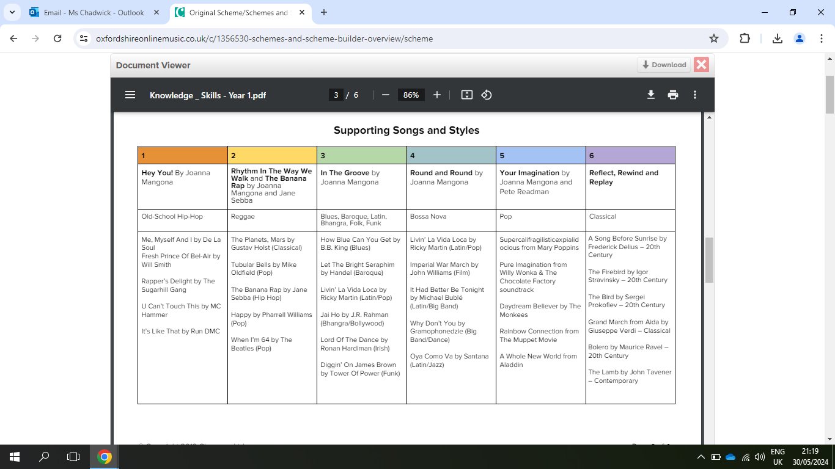
Continuous provision | Artist of the week and composer of the week during whole school assembly.  Lower School Singing assembly Tuesday (see attached for list)
Retrieval practice | Retrieve Artist or Composer of the week information during Friday assembly.  Play song of the term at other times in the week
Year group 2 | Watch and follow a steady beat. Find a steady beat. Recognise the time signature 4/4 by ear and notation. Understand that the speed of the beat can change, creating a faster or slower pace (tempo). | Recognise long and short sounds and match them to syllables and movement. Play copy back rhythms, copying a leader, and invent rhythms for others to copy on untuned and tuned percussion. Create rhythms using word phrases as a starting point. | Identify the high notes and low notes in a melody. Join in with part of a melody. Rehearse and play a simple instrumental melody as a part to go with a song. Identify the names of the notes on a glockenspiel: C, D, E, F, G, A, B, C. Use body percussion, untuned and tuned percussion instruments with a song, and listen to how the sounds blend together. Identify and play by ear or notation notes in the tonality of C major. | Recognise the difference between the speed of a steady beat, a fast beat and a slow beat. Change the speed of a steady beat, moving from fast to slow, slow to fast. Understand that the speed of the beat can change, creating a faster or slower pace. | Identify loud and quiet sections of music and discuss what makes the music loud or quiet. Understand the meaning of loud and quiet (forte and piano). | Know the difference between a speaking voice and a singing voice. Identify friends from the sound of their voices. | Understand that singing and playing together creates a musical texture. Add body percussion accompaniments. | Join in with a repeated section of a song: the chorus, the response. Join in with the main tune when it is repeated.
Vocabulary | Keyboard, drums, bass, electric guitar, saxophone, trumpet, pulse, rhythm, pitch, improvise, compose, audience, question and answer, melody, dynamics, tempo, perform/performance, audience, rap, reggae, glockenspiel.
Evolving Musical Repertoire | The children will be taught to use the following musical terms whilst singing and listening:  Pitch: High and Low  Key: D and C  Duration and Rests: Crotchets, dotted crotchet, quaver, minims, semibreves and rests  Notes: F, G, A, B♭ (A♯) + C, D, E, F + G Recorder Notes: B, A and G.  Children will have an awareness of their evolving musical repertoire whilst performing and will be taught the importance of and the skills associated with this. Children will listen and respond to music by learning to sing these songs and experiencing these genres of music:  Charanga Songs I Wanna Play in a Band, Zootime  Styles Rock and Reggae  Recorder Songs Hey You!, Easy B, Take It Easy, Strictly B, Play Your Music, Drive, Shakes and Breaks, Good, Better, Best, ABBA, Abie’s Blues, What’s Up, March of the Golden Guards, Mardi Gras Groovin, Seven G’s, Portsmouth.
Supporting Songs and Styles | We Will Rock You by Queen, Smoke On The Water by Deep Purple, Rockin’ All Over The World by Status Quo, Johnny B.Goode by Chuck Berry, I Saw Her Standing There by The Beatles + Kingston Town by UB40, Shine by ASWAD, IGY by Donald Fagen, Feel Like Jumping by Marcia Griffiths, I Can See Clearly Now by Jimmy Cliff
Continuous provision | Artist of the week and composer of the week during whole school assembly.  KS2 Singing assembly Tuesday.  Retrieve Artist or Composer of the week information during Friday assembly.  Recorder tuition - Autumn and Summer Term
Retrieval practice | Flash cards to teach/remind children vocabulary for year group.
,

Launton Church of England Primary School

Music Lower KS2

 | Pulse/Beat/Metre | Rhythm | Pitch (melody) | Tempo | Dynamics | Timbre | Texture | Structure (form)
Year group 3  Recorder for two terms | Recognise and move in time with the beat. Play the steady beat on percussion instruments. Recognise the 'strong' beat. Play in time with a steady beat in 2/4, 4/4 and 3/4. | Recognise by ear and notation: minims, crotchets, quavers and their rests. Copy simple rhythm patterns created from minims, crotchets, quavers and their rests. Create simple rhythm patterns by ear and using simple notation from minims, crotchets, quavers and their rests. Alternate between a steady beat and rhythm. | Show the shape of a melody as rising and falling in pitch. Learn to sing a melody by ear or from notation. Learn to rehearse and play a melodic instrumental part by ear or from notation. Identify the names of the pitched notes on a stave: C, D, E, F, F♯, G, A, B, B♭, C. Identify the scales of: C major G major F major Identify if a scale is major or minor. Copy simple melodies by ear or from reading notation. Create melodies by ear and notate them. Explore and play by ear or from notation: • Five-note scale • Pentatonic scale | Recognise the difference between the speed of a steady beat, a fast beat and a slow beat. Change the speed of a steady beat, moving from fast to slow, slow to fast. Control the speed of a steady beat, getting faster and getting slower. | Listen out and respond to forte (loud) sections of music. Identify instruments playing loud dynamics when listening to the music. Use dynamics to help communicate the meaning of a song. | Choose particular instruments for rehearsal and performing. Identify the sound of different tuned and untuned percussion instruments. | Understand that singing and playing together creates a musical texture. Add body percussion accompaniments. Listen to the accompaniment to a song. Identify large numbers of people playing and singing. Listen out for solo players. | Show the different sections of a song structure or piece of music through actions.
Vocabulary | Structure, intro/introduction, verse, chorus, improvise, compose, pulse, rhythm, pitch, tempo, dynamics, bass, drums, guitar, keyboard, synthesizer, hook, melody, texture, structure, electric guitar, organ, backing vocals, hook, riff, melody, Reggae, pentatonic scale, imagination, Disco.
Evolving Musical Repertoire | The children will be taught to use the following musical terms whilst singing and listening:  Notes D, E, G, A + B  Duration and rests Semibreves, minims, dotted crotchets, crotchets, quavers and semiquavers  Key Predominantly C and G  Children will have an awareness of their evolving musical repertoire whilst performing and will be taught the importance of and the skills associated with this. Children will listen and respond to music by learning to sing these songs and experiencing these genres of music:  Songs Let Your Spirit Fly, Glockenspiel Stage 1, Three Little Birds, The Dragon Song, Bringing Us Together.  Styles RnB, Reggae, Pop, Disco, Classical
Supporting Songs and Styles | 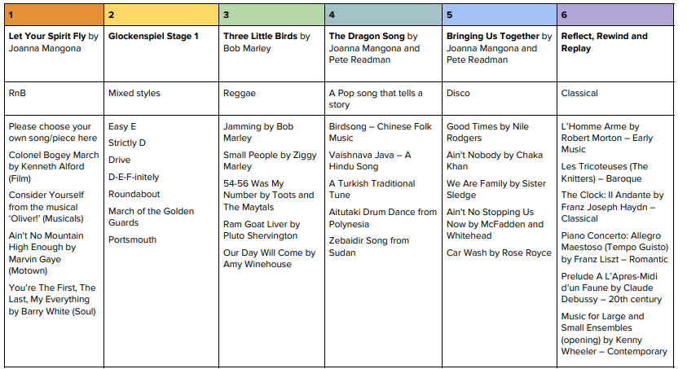
Continuous provision | Artist of the week and composer of the week during whole school assembly.  KS2 Singing assembly Tuesday.
Retrieval practice | Flash cards to teach/remind children vocabulary for year group.  Retrieve Artist or Composer of the week information during Friday assembly.
Year group 4  First Access Brass Programme | Developing an understanding of the term pulse  Clapping the pulse to different pieces of music (at different speeds in different styles)  Learn to read the note C on a treble clef stave | Develop an understanding of the term rhythm  Develop an understanding of the different between pulse and rhythm  Develop understanding of the note lengths semibreve, minim and crotchet  Develop understanding of semibreve, minim and crotchet rests  Learn to recognise semibreve, minim and crotchet plus their rests from musical notation | Develop an understanding of the term pitch  Develop understanding between notes going higher on a stave and sounding higher  Learn to read the notes C, D, E, F and G on a treble clef stave  Develop understanding of scale/octave | Develop an understanding of the term tempo  Develop an understanding of the terms lento, andante and presto  Develop an understanding of the terms rallentando and accelerando  Be able to listen to a piece of music and describe the tempo/how tempi change mood of piece  Learn how tempi are shown on musical notation | Develop an understanding of the term dynamics  Develop an understanding of the terms pianissimo, piano, forte and fortissimo  Develop an understanding of the terms diminuendo and crescendo  Be able to listen to a piece of music and describe the dynamic/how dynamics change mood of piece  Learn how dynamics are shown on musical notation | Explain tone colour: the instruments or voices heard that can be recognised by their unique qualities. Recognise the difference between the sound of high and low voices. Understand the importance of the vocal warm-up and its impact on the tone of the voice. | Harmony and Unison  Develop an understanding of the terms Harmony/Unison and the difference between the two | Performance  Develop performance skills such as lifting instruments together at start of music/freezing at end  Prepare for and give end of year concert
Vocabulary | improvise, compose, melody, pulse, rhythm, pitch, tempo, dynamics, texture, structure, compose, improvise, hook, riff, melody, solo, pentatonic scale, unison, rhythm patterns, musical style, by ear, notation, backing vocal.
Evolving Musical Repertoire | The children will be taught to use the following during their First Access Brass Programme  Instrumental Work:  Learning how a sound is made on an instrument (vibration), Learning how to buzz lips to create a sound on a brass instrument, Buzzing in time to pieces of music, Learn to play the note C and copy back simple patterns on the note C.  Copy back simple rhythms using semibreve, minim and crotchet, Compose simple rhythms using semibreve, minim and crotchet, Play pieces using semibreve, minim and crotchet, reading from notation, Develop understanding of how tongue is used at the start of a note.  Learning how to 'bend' the pitch on a brass instrument using lips and air flow, Learn to play the pitches D, E, F and G on a brass instrument, Learn to play High A, Low A and Low B.  Learn how to change the dynamic on a brass instrument, Develop understanding of how this can sometimes effect pitch by mistake, Perform pieces using a range of different dynamics.  Learn to play melodies at different speeds on brass instruments, Develop understnading of relationship between tempo and pulse, Consider how tempo and dynamics can sometimes be linked.  Learn to play multi part pieces, Learn to focus on one part whilst other parts are being played, Perform pieces learnt throughout the year.  Songs Seven Cs, Mountain Song, C Crotchets, C minims, Elevator Song, Ones and Twos, Drive, C and D stroll, C and D jog, Dee Cees Blues, Hot Cross Buns, Old Macdonald, When the saints, Fishy Scales, Boom-chikka-boom, DEFinitely, Tempo Song, Boogey Shoes, Rock Today.
Continuous provision | Artist of the week and composer of the week during whole school assembly.  KS2 Singing assembly Tuesday.  Oxfordshire Music Service “First Access” Brass Lesson.  Children take home their brass instrument for daily practise.
Retrieval practice | Flash cards to teach/remind children vocabulary for year group.  Retrieve Artist or Composer of the week information during Friday assembly.

Launton Church of England Primary School

Music Upper KS2

 | Pulse/Beat/Metre | Rythmn | Pitch (melody) | Tempo | Dynamics | Timbre | Texture | Structure (form)
Year group 5 | Recognise and move in time with the changing speed of a steady beat. Play in time with a steady beat and identify the metres 2/4, 4/4, 3/4, 5/4 and 6/8. Respond to the 'offbeat' or 'backbeat'. | Recognise by ear and notation: • Minims, dotted crotchets, crotchets, quavers and their rests Recognise by ear and notation: • 6/8 rhythm patterns • Dotted crotchets, triplet quavers, dotted quavers, quavers and their rests Recognise dotted rhythm in melodies. Copy simple rhythm patterns using the above rhythms. Create rhythm patterns by ear and using simple notation, which use the above rhythm patterns. Recall the most memorable rhythms in a song or piece of music | Identify and explain steps, jumps and leaps in the pitch of a melody. Learn to sing and follow a melody by ear and from notation. Learn to play one or more of four differentiated melodic instrumental parts by ear and from notation. Identify the names of the pitched notes on a stave: C, D, E, E♭, F♯, G, A, B, B♭, C, C♯, D. Identify the following scales by ear or from notation: C major, F major, D minor, G major, E♭ major, C minor. Copy simple melodies by ear or from reading notation. | Recognise the difference between the speed of a steady beat, a fast beat and a slow beat. Change the speed of a steady beat, moving from fast to slow, slow to fast. Control the speed of a steady beat, getting faster and getting slower. Direct the class in controlling the speed of a steady beat in a class performance. Recognise the connection between tempi and musical styles. | Identify dynamics and how they change the mood and feel of the music: forte, piano, mezzo forte, mezzo piano, crescendo and diminuendo. | Recognise the following ensembles: • Gospel choir and soloist • Rock band • Symphony orchestra • A Cappella group Identify the following instruments by ear and through a range of media: drum kit, electric guitar, electric bass guitar, acoustic guitar, keyboard or Hammond organ, synthesiser, saxophone, trumpet, harmonica, banjo, accordion, tuned and untuned percussion, steel pans and instruments of the orchestra such as clarinet, tuba, violin, trombone and flute. Recognise the difference between the sound of high and low voices. Recognise tone colour and rapping | Identify solos and instrumental breaks in songs and music. Talk about solo voices, backing vocals and different vocal textures. Identify changes in texture. Talk about the different textures created by intervals and chords. | Identify and explain the structural terms: verse, chorus, bridge, repeat signs, chorus and final chorus, improvisation, call and response, and AB form within musical structures. Identify the instrumental break and its purpose in a song. Recognise phrases and repeated sections. Discuss the purpose of a bridge section.
Vocabulary | Rock, bridge, backbeat, amplifier, chorus, bridge, riff, hook, improvise, compose, appraising, Bossa Nova, syncopation, structure, Swing, tune/head, note values, note names, Big bands, pulse, rhythm, solo, ballad, verse, interlude, tag ending, strings, piano, guitar, bass, drums, melody, cover, Old-school Hip Hop, Rap, riff, synthesizer, deck, backing loops, Funk, scratching, unison, melody, cover, pitch, tempo, dynamics, timbre, texture, Soul, groove, riff, bass line, brass section, harmony, melody.
Evolving Musical Repertoire | The children will be taught to use the following musical terms whilst singing and listening:  Pitch C, G, A♭, B♭, F, A, D, E, F♯, G, E♭  Duration Minims, dotted minims, dotted crotchets, crotchets, quavers dotted quavers semiquavers, triplet quavers  Rests Minims, dotted minims, dotted crotchets, crotchets, quavers dotted quavers semiquavers, triplet quavers  Key A minor, C minor, G major, F major, E♭major, C major, D minor, D major  Time signature 2/4, 4/4, 6/8, 3/4, 5/4  Children will have an awareness of their evolving musical repertoire whilst performing and will be taught the importance of and the skills associated with this.  Children will listen and respond to music by learning to sing these songs and experiencing these genres of music:  Songs Livin’ on a prayer, Classroom Jazz 1, Make you feel my love, Fresh Prince of Bell Air, Dancing in the Street.  Style Rock anthems, Bossa nova and swing, Jazz and improvisation, pop ballads, Old school hip hop, Mo-town.
Supporting Songs and Styles | 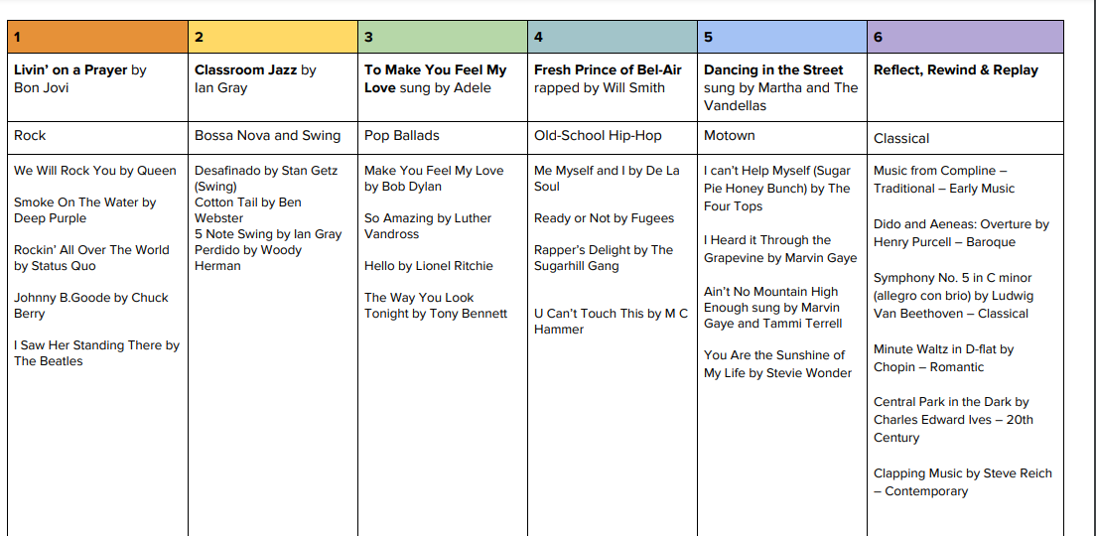
Continuous provision | Artist of the week and composer of the week during whole school assembly.  Singing assembly Tuesday.  “Play On” Brass Lessons offered.
Retrieval practice | Flash cards to teach/remind children vocabulary for year group.  Retrieve Artist or Composer of the week information during Friday assembly.
To be taught in 2025-26

Year group 6 | Recognise and move in time with the changing speed of a steady beat. Play in time with a steady beat and identify the metres 2/4, 4/4, 3/4, 6/8 and 5/4. Identify syncopation and swing. | Recognise by ear and notation: • Minims, crotchets, quavers, semiquavers and their rests Recognise by ear and notation: • 6/8 rhythm patterns • Dotted crotchets, triplet quavers, dotted triplet quavers, quavers and their rests Recognise by ear and notation: • 9/8 rhythm patterns • Dotted crotchets, triplet quavers and quaver notes and their rests Recognise dotted rhythm in melodies. Copy simple rhythm patterns using the above rhythms. Create rhythm patterns by ear and using simple notation, that use the above rhythm patterns. Recall the most memorable rhythms in a song or piece of music | Identify major and minor tonality by ear and from notation Learn to play one or more of four differentiated melodic instrumental parts, by ear and from notation. Identify the names of the pitched notes on a stave: C, D, E, E♭, F♯, G, A, B, B♭, C, C♯, D. Identify the following scales by ear or from notation: A minor, G major, D major, D minor, F major. Identify an interval of a major triad: 3rd, 5th. Identify an octave by ear or notation. Copy simple melodies by ear or from reading notation. Create melodies by ear and notate them. Use chords C, F, G and A minor by ear or from notation. Identify the tonal centres of: A minor, G major, D major, D minor, F major. Identify and demonstrate the following scales by ear and from notation: Major scale, minor scale, pentatonic scale, blues scale | Recognise the difference between the speed of a steady beat, a fast beat and a slow beat. Change the speed of a steady beat, moving from fast to slow, slow to fast. Control the speed of a steady beat, getting faster and getting slower. Direct the class in controlling the speed of a steady beat in a class performance. Recognise the connection between tempi and musical styles. Recognise an effective use of tempo at the end of a son | Identify how dynamics change the mood and feel of music using vocabulary: forte, piano, mezzo forte, mezzo piano, crescendo and diminuendo. Identify how dynamics can support the structure of a song or piece of music, eg diminuendo leading into a new section and change of mood. Identify the connection between dynamics and texture, eg adding more players and/or singers makes the music louder. | Recognise the following ensembles: • Pop group • A Cappella group • Gospel choir Identify instruments that add particular colour to a song or piece of music. Identify the following instruments by ear and through a range of media: • Band instruments such as keyboard, electric or Hammond organ, saxophone, trumpet, electric guitar, electric bass guitar, drum kit, vocals, drum machine and synthesiser. • Instruments of the orchestra from the strings, woodwind, brass and tuned and untuned percussion families, particularly violin, cello, double bass, flute, clarinet, oboe, saxophone, trumpet, trombone, French horn, tuba, drums (timpani), glockenspiel, xylophone and piano. • Other instruments such as steel pans, harmonica, banjo and accordion. | Sing and play instruments in different-sized groups. Identify solos and instrumental breaks in songs and music. Talk about solo voices, backing vocals and different vocal textures. Refer to repeated rhythmic or melodic patterns as riffs/ostinati. Talk about the different textures created by intervals and chords. Understand how texture builds throughout a piece as voices are layered. | Talk about how musical styles often have the same musical structure, eg Folk music: verse and chorus; Rock and Pop music: verse, chorus, bridge and instrumental break. Talk about the purpose of musical structures. Identify where changes in texture and tonality help emphasise the contrasting sections in a song. Recognise that changing the tonality at different points within the song creates different sections to the structure.
Vocabulary | style indicators, melody, compose, improvise, cover, pulse, rhythm, pitch, tempo, dynamics, timbre, texture, structure, dimensions of music, Neo Soul, producer, groove, Motown, hook, riff, solo, Blues, Jazz, improvise/improvisation, by ear, melody, riff, solo, ostinato, phrases, unison, Urban Gospel, civil rights, gender equality, unison, harmony
Evolving Musical Repertoire | The children will be taught to use the following musical terms whilst singing and listening:  Pitch C, D, E, F, G, A, B, B♭, F♯, C♯, G♯, A♭  Duration Minims, dotted crotchets, crotchets, dotted quavers, quavers, semiquavers, dotted minims, triplet quavers  Rests Minims, dotted crotchets, crotchets, dotted quavers, quavers, semiquavers, dotted minims, triplet quavers  Key C major, G major, D major, A minor, D minor, E♭major, F major, A major, F minor  Time Signature 2/4, 4/4, 3/4, 5/4  Children will have an awareness of their evolving musical repertoire whilst performing and will be taught the importance of and the skills associated with this.  Children will listen and respond to music by learning to sing these songs and experiencing these genres of music:  Songs Do What You Want To Fanfare For The Common Man It’s All About Love Main Title Theme (From Schindler’s List) Sunshine On A Rainy Day My Best Friend Why The Rite Of Spring, Pt. 1 Adoration Of The Earth - No. 1 Introduction Singing Swinging Star Roll Alabama Disco Fever 1812 Overture La Bamba Vakuru (Elders) Change Let’s Rock Mazurka In G Minor, Op. 24 No. 1 Simple Gifts Danny Boy Friendship Should Never End Wake Up! We Shall Overcome Down By The Riverside You Belong With Me Dance The Night Away Heal The Earth My Funny Valentine Let’s Go Surfin’ So Amazing  Styles Soul Pop 20th and 21st Century Orchestral Hip Hop Jazz: Swing Rock Disco Romantic Rock ‘n’ Roll Zimbabwean Pop Folk Gospel Salsa Reggae Musicals Film Music
Continuous provision | Artist of the week and composer of the week during whole school assembly.  Singing assembly Tuesday.  “Play On” Brass Lessons offered.
Retrieval practice | Flash cards to teach/remind children vocabulary for year group.  Retrieve Artist or Composer of the week information during Friday assembly.

